**Sales Performance Analysis Dashboard using Power BI**

**Abstract**

This project focuses on utilizing Power BI to analyze and visualize e-commerce sales data, providing businesses with actionable insights to enhance performance and drive growth. The dashboard highlights key metrics including sales revenue, product performance, customer behavior, and marketing effectiveness. Power BI’s interactive features, such as dynamic dashboards and real-time analytics, enable businesses to make informed decisions quickly. The analysis helps optimize inventory management, marketing strategies, and customer engagement, ultimately improving profitability.

**Introduction**

The E-commerce sales data, enabling businesses to gain valuable insights into their performance. By integrating data from various sources like customer, product, and order tables, Power BI helps track key metrics such as sales revenue, product performance, and customer behavior. The platform's interactive dashboards and rich visualizations allow decision-makers to make data-driven decisions in real time, optimizing marketing, inventory, and sales strategies for business growth.

**Objectives:**

1. **Analyze E-Commerce Sales Performance**: To track and visualize key sales metrics such as Average Sale Price, Average Customer Rating, sales growth over time using Power BI.
2. **Optimize Marketing Campaign Effectiveness**: To assess the impact of promotions, discounts, and advertising campaigns on sales performance and ROI.
3. **Enhance Decision-Making**: To provide interactive, real-time dashboards that enable business stakeholders to make data-driven decisions on inventory management, marketing initiatives, and overall sales strategy.
4. **Improve Regional and Demographic Sales Insights**: To visualize and analyze sales performance by region, customer segment, and product category to optimize market penetration and target specific customer groups more effectively.

**Analysis Approach**

The Main aim is to gain actionable insights that drive business decisions.

**Task 1:** **Analysis of the Requirements regarding the project.**

Analyzing the requirements for a project involving an e-commerce sales dataset involves identifying the key business goals, understanding the dataset structure, and determining the analytical tools and techniques required to meet those goals.

**Task2- Collecting a Dataset**

**Customer Table**

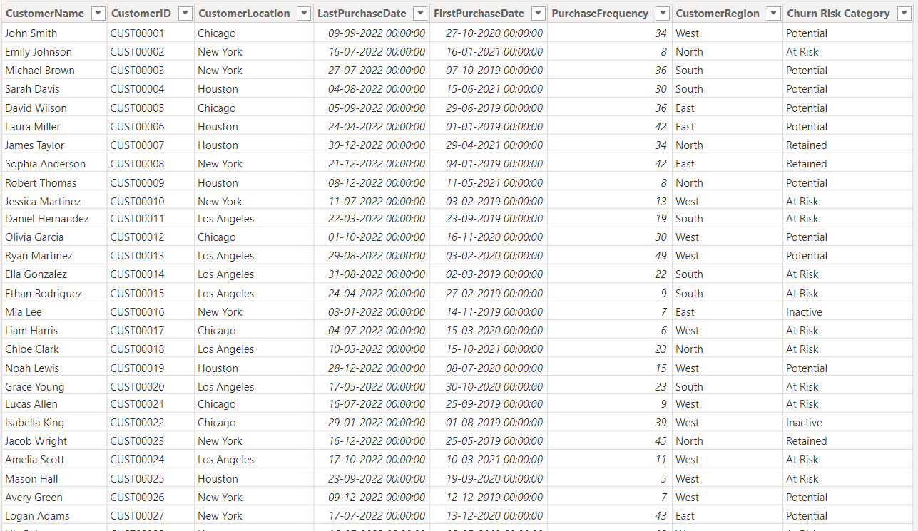

**Product Table**

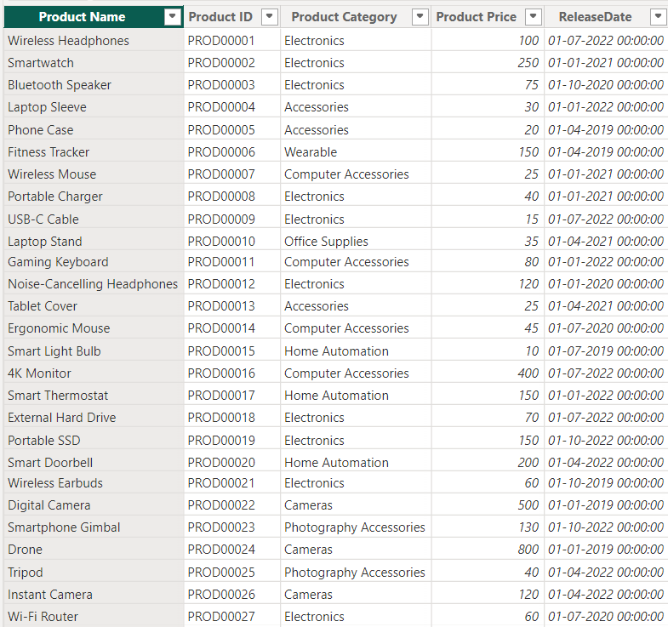

**Salesperson Table**

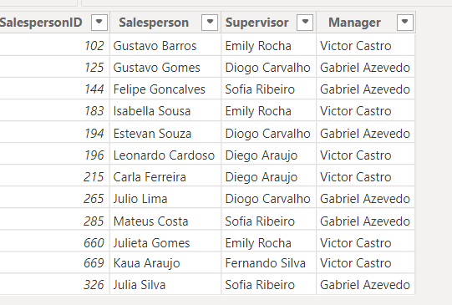

**Sales Table**

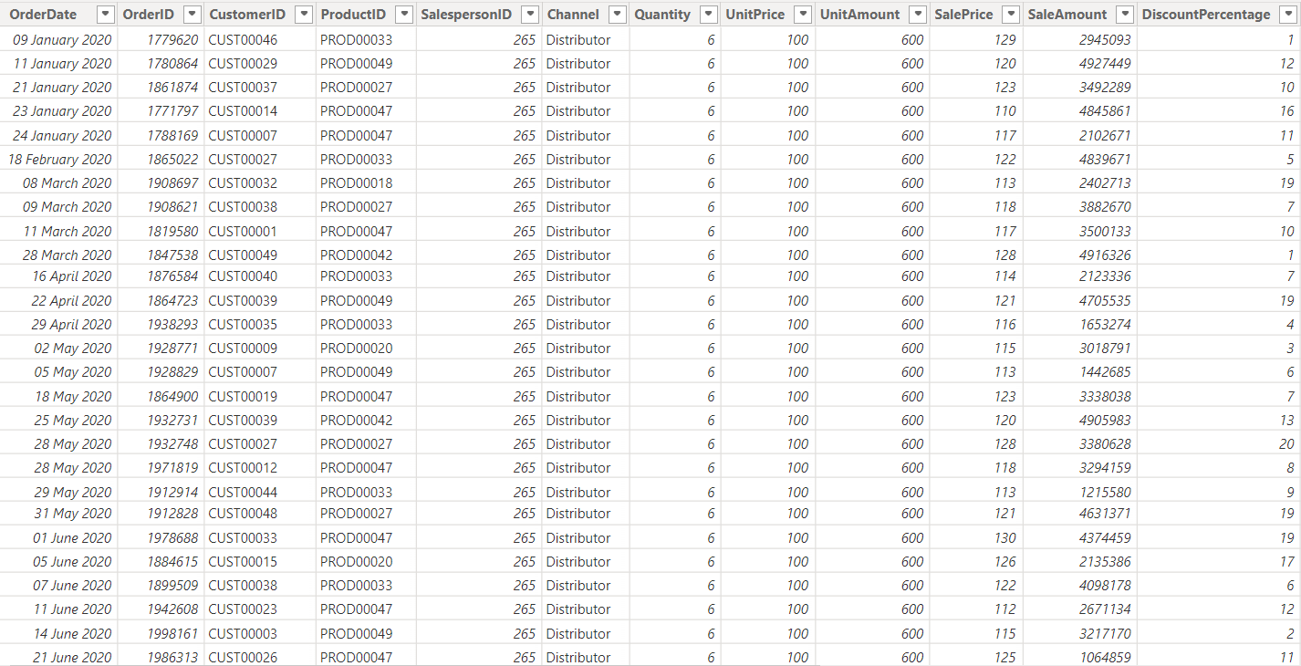

**Task 3-Working with the Dataset using DAX Formulas-**

Working with a dataset using DAX (Data Analysis Expressions) formulas involves creating calculated columns, measures, or tables that enable dynamic data analysis.

* **Total Sales (Measure)**: Total Sales = SUM(Sales_Orders[Sales_Amount])
* **CLTV by Product Category** = CALCULATE(

SUM(SalesTable[SaleAmount]), ALLEXCEPT(ProductTable, ProductTable[Product Category]))

**Product Sales Cannibalization Analysis**

* **Product Status =** IF(DATEDIFF(ProductTable[ReleaseDate], TODAY(), YEAR) <= 2, "New", "Existing")
* **Churn Prediction and Retention Insights**

**Recency =** DATEDIFF(MAX(CustomerTable[LastPurchaseDate]), TODAY(), DAY)

* **Customer Count by Category =**

CALCULATE(

    DISTINCTCOUNT(CustomerTable[CustomerID]),

    FILTER(

        CustomerTable,

        CustomerTable[Churn Risk Category] = SELECTEDVALUE(CustomerTable[Churn Risk Category])

    )

)

**Task4: Customer Segmentation using DAX Data Transformation**

Used IF condition to categorize the data in different segments such as:

* **Churn Risk Category** =

SWITCH(

    TRUE(),

    [Recency] > 980, "Inactive",

    [Recency] > 750 && CustomerTable[PurchaseFrequency] <= 28, "At Risk",

    [Recency] <= 750 && CustomerTable[PurchaseFrequency] > 28, "Retained",

    TRUE(), "Potential"

)

* **Customer Sentiment Analysis**

**Average Customer Rating** = AVERAGE(SalesTable[CustomerRating])

* **New vs. Repeat Customer Sales Trends**

**Customer Type** =

VAR FirstPurchaseDate =

CALCULATE(

MIN(CustomerTable[FirstPurchaseDate]),

FILTER(

CustomerTable,

CustomerTable[CustomerID] = SalesTable[CustomerID]

)

)

RETURN

IF(

SalesTable[OrderDate] <= FirstPurchaseDate + 365,

"New",

"Repeat"

**)**

**Task5: Making a visual for displaying the sales trend**

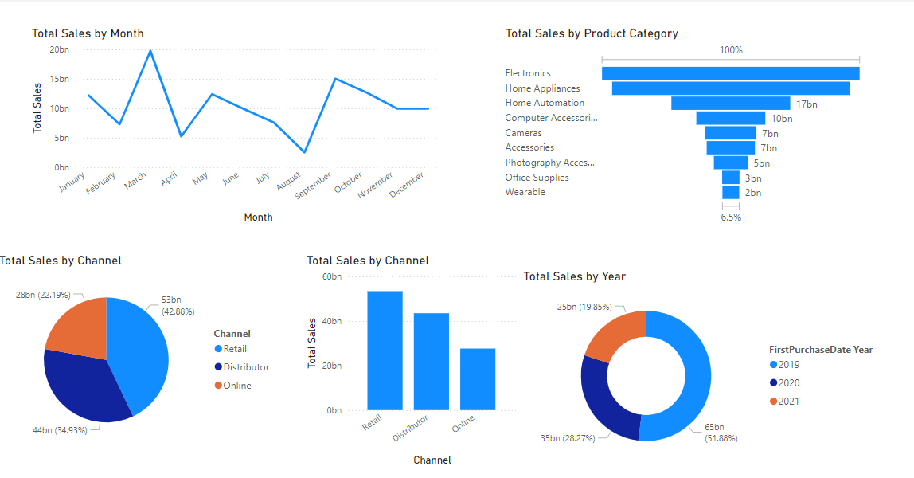

**Proposals**

**Part 1 - Product Sales Cannibalization Analysis**

Product Sales Cannibalization Analysis involves evaluating the impact of a new product on the sales of existing products. It assesses whether the new product is taking away sales from existing products, rather than attracting new customers or increasing overall revenue. This analysis helps businesses understand and mitigate potential losses due to internal competition.

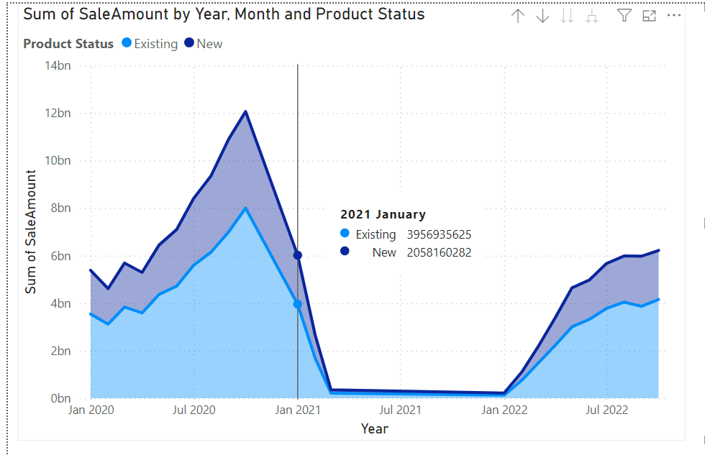

**Key Insight:** If "Existing" product sales decline as "New" product sales increase, this indicates possible cannibalization.

**This chart shows fluctuations in sales, particularly during new product introductions**

**helping their impact on existing products.**

**Part 2 - Customer Lifetime Value (CLTV) Analysis**

Customer Lifetime Value (CLTV) Analysis calculates the total revenue a business can expect from a customer over the entire duration of their relationship. It helps businesses identify high-value customers, optimize marketing strategies, and make data-driven decisions for long-term profitability.

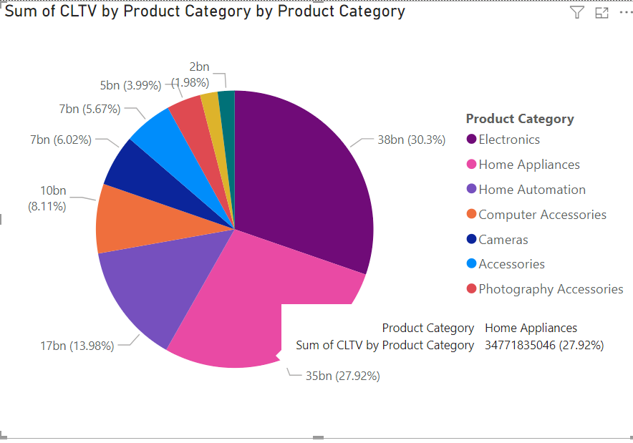

**Key Insight:** Identify high-value product categories that generate sustained customer revenue, supporting strategic focus.

**This chart shows Electronics and Home Appliances as top contributors to CLTV, helping prioritize resource allocation.**

**Proposal Part 3 - Churn Prediction and Retention Insights**

Churn Prediction involves identifying customers who are likely to stop using a product or service, allowing businesses to take proactive measures. Retention Insights focus on understanding the factors that influence customer loyalty and satisfaction, enabling strategies to reduce churn and improve long-term engagement.

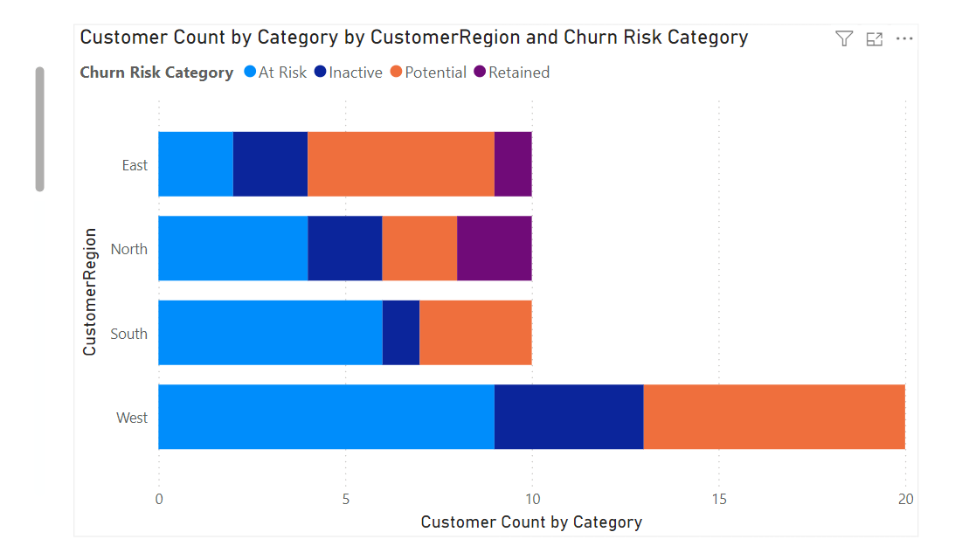

**Key Insight:** Regional churn analysis helps to understand areas with higher risk, guiding targeted retention strategies.

**The chart reveals that the West region has the highest number of at-risk customers, prompting potential focus on engagement initiatives in that area.**

**Proposal Part 4 - Customer Sentiment Analysis**

It helps businesses understand customer satisfaction, identify areas for improvement, and tailor marketing strategies based on customer emotions and feedback.

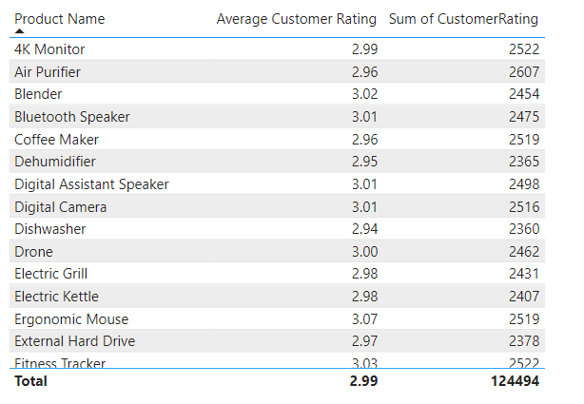

**Key Insight:** Tracking feedback trends to improve strategies and customer experience.

**Average customer ratings were calculated and summarized by product categories to identify high- and low-performing segments**

**Part 4 - Customer Sentiment Analysis**

Customer Sentiment Analysis visually represents customer feedback by categorizing sentiments (positive, negative, neutral) across different attributes or products. It uses color coding and size variations to highlight sentiment trends, helping businesses quickly identify areas of strength, issues, and emerging patterns in customer opinions.

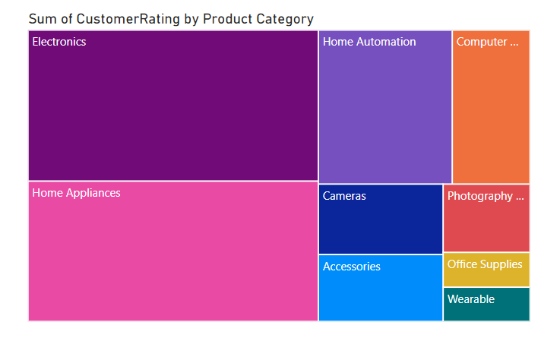

**Key Insight:** Visual overview of sentiment distribution, enabling businesses to quickly pinpoint areas with the most positive or negative feedback, and prioritize improvements or marketing strategies accordingly**.**

**Positive customer sentiment in key categories may drive higher sales, aiding in prioritizing product improvement efforts for lower-rated categories.**

**Part 5 - New vs. Repeat Customer Sales Trends**

Differentiate sales trends between new and returning customers to analyze customer loyalty and acquisition effectiveness

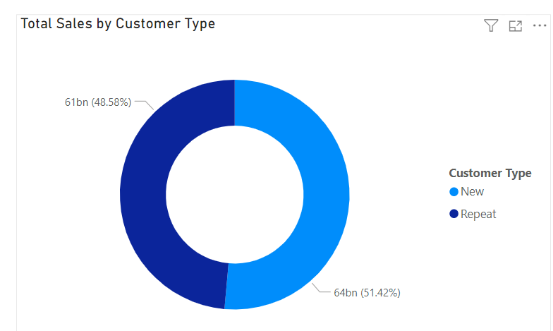

**Key Insight:** Shows total sales proportion contributed by new vs. repeat customers.

**Displays the proportion of total sales between new and repeat customers**

**Line Chart:** Tracks monthly sales trends for both customer types over time, highlighting sales performance peaks and customer retention success.

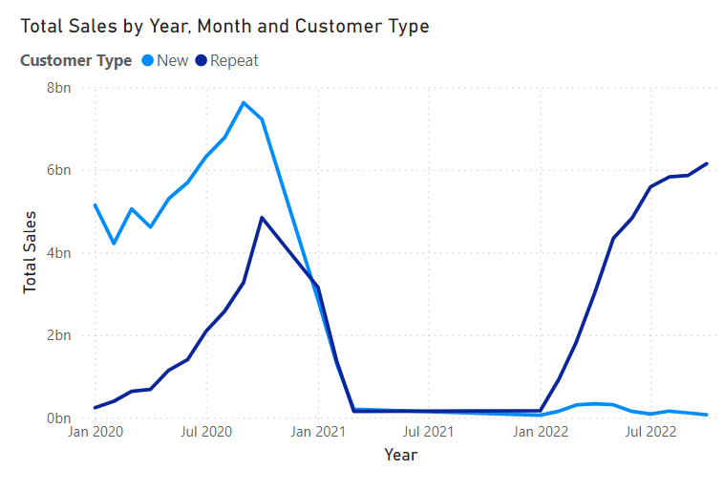

**Part 6 - Geo-Spatial Sales Trends**

Map sales distribution by customer location to identify regions with high sales potential and growth trends.

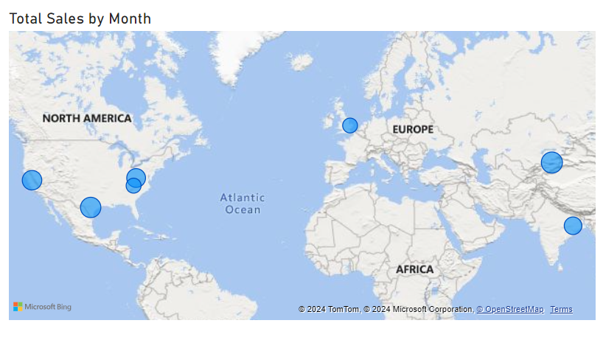

**Key Insight:** Helps identify regions with significant sales contributions, enabling targeted marketing strategies.

**Displays sales volume by geographic location with bubble size representing total sales. Allows users to observe monthly sales patterns across regions.**

**Customer Analysis Based Visualizations**

* 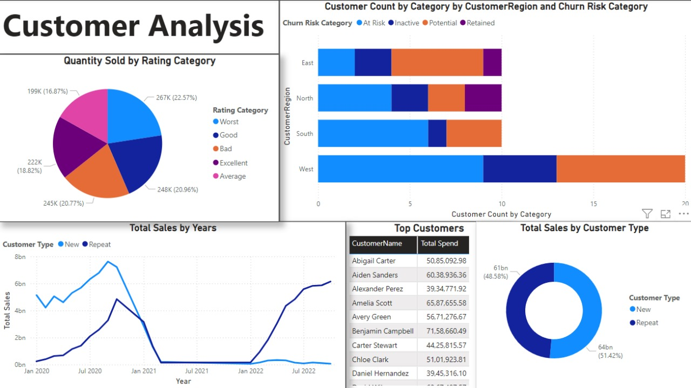

**Sales Analysis Based Visualizations**

* 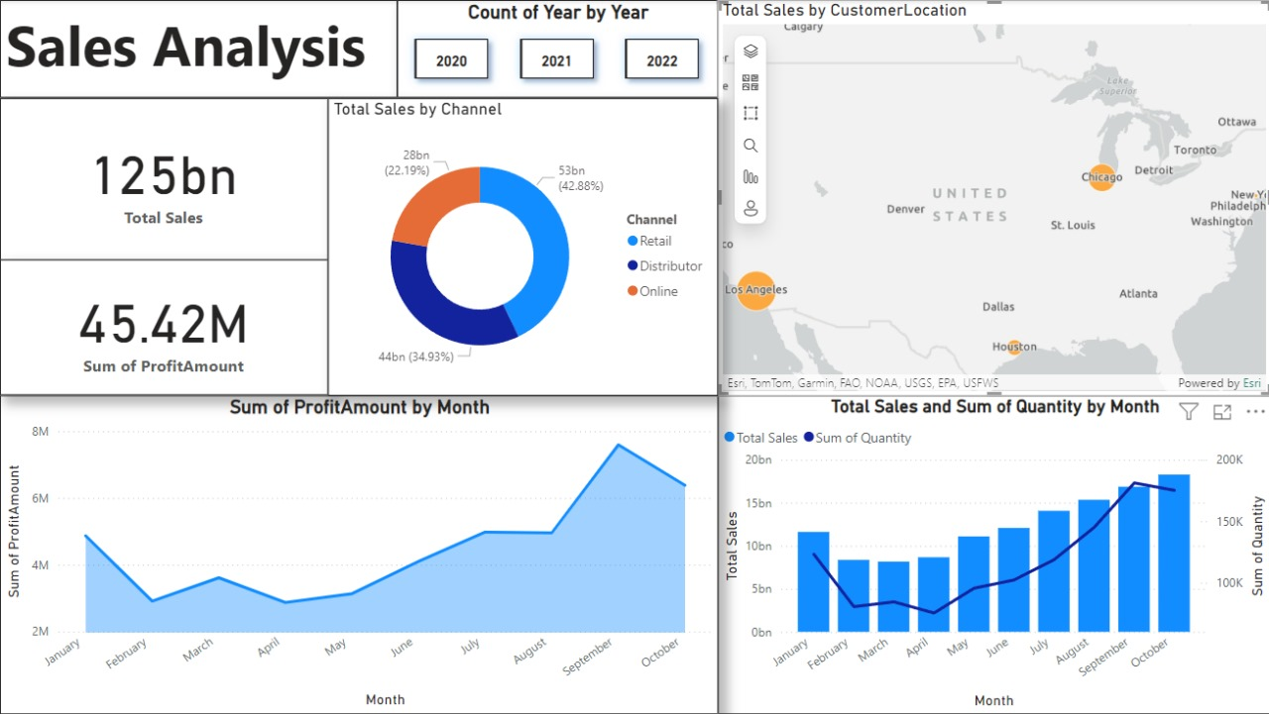

**Product Analysis Based Visualizations**

* 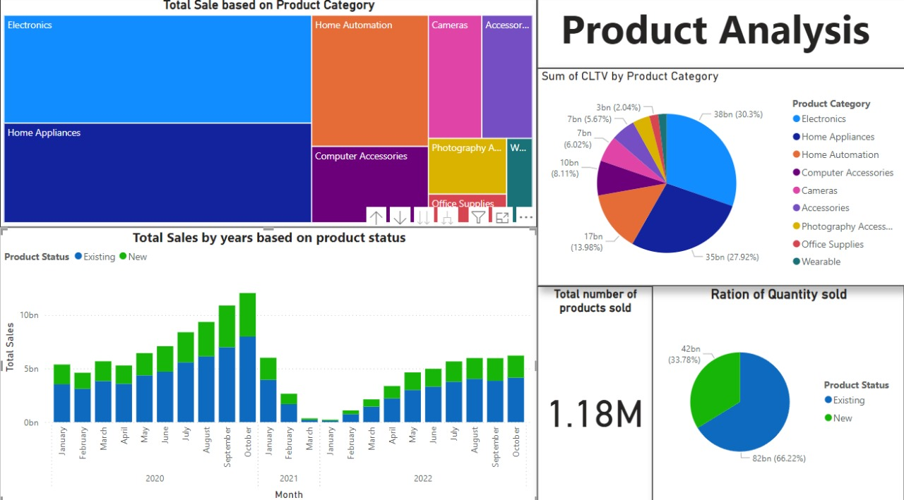

**Conclusion**

* The Sales Performance Dashboard provides a comprehensive view of sales dynamics, customer behavior, and product trends.
* Key analyses, including CLTV, churn risk, and product sales cannibalization, offer actionable insights to drive business growth and customer retention.
* Visualizations like dual-axis charts, pie charts, and geographic mapping make complex data easily interpretable.
* This dashboard enables data-driven decision-making, supporting strategies for targeted marketing, improved customer satisfaction, and optimal resource allocation.

**Future Enhancements**

* Advanced Customer Segmentation
* Sales Forecasting and Predictive Analytics
* Marketing Campaign Impact Analysis
* Enhanced Geo-Spatial Sales Analysis
* Product Sales Velocity
* Improved Customer Lifetime Value (CLTV) Metrics